Kidding Problems (Dystocia) and How to Help Them
Anterior position;
Anterior position with head and neck to one side.
Normal anterior birthing position.
Breech position with one rear leg retained.
Breech position.
Breech Rump Fist.
Anterior position with fetus upside down.
Back presenting.
Front legs presenting, but head is back.
Front legs presenting, but head down ventrally.
Head and legs flexed and upside down.
Double trouble
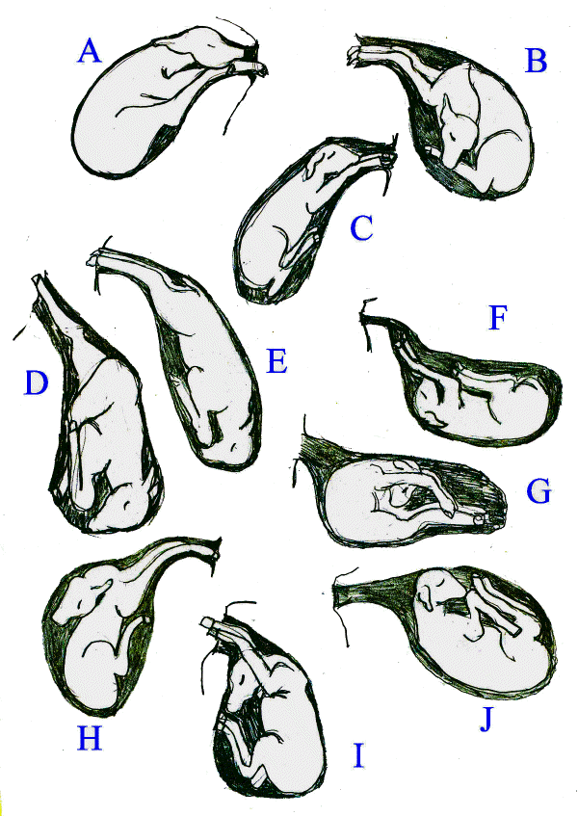
Kidding Problems (Dystocia) and How to Help Them
K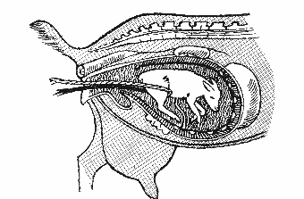
L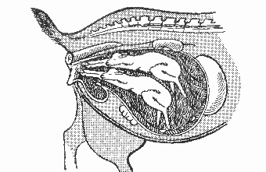

Kidding Problems (Dystocia) and How to Help Them
A. Anterior position; hind legs in the pelvic canal. Hind legs must be pushed back out of the canal while maintaining traction on the forelegs. Once back legs are pushed back, delivery will occur in the normal position (C).
B. Anterior position with head and neck to one side. Head must be brought forward and into the pelvic canal. This is a difficult birth so be patient. Once head is straightened and in the pelvic canal, delivery will occur in the normal position (C).
C. Normal anterior birthing position. Two front legs followed by the nose.
D. Breech position with one rear leg retained. Push forward on the leg presented and bring the retained leg into position by hooking a finger in front of the thigh and gently pulling the rear leg towards you. Deliver in the breech position (E).
E. Breech position. This is a common position, especially in cases of triplets. This position can be delivered just fine, but may need to be pulled.
F. Anterior position with fetus upside down. Rotate 180 degrees and delivery will occur in the normal position (C).
G. Back presenting. This is a very difficult malposition to deal with due to the lack of space to maneuver. Care must be taken not to push the legs through the uterine wall when maneuvering the kid. Use fingers to roll kid until you can get the kid in either an anterior or a breech position. Once in anterior or breech, determine its new position (A-J) and then see A-J for what to do next.
H. Front legs presenting, but head is back. Push front legs back to get room and then bring the head into position. Delivery will occur in the normal position (C).
I. Front legs presenting, but head down ventrally. Push head and shoulders back and bring nose up into position. Delivery will occur in the normal position (C).
J. Head and legs flexed and upside down. Rotate 180 degrees, bring head and front legs into pelvic canal. Delivery will occur in the normal position (C).
K. Breach-Rump First. This baby will not be able to pass through the birth canal. The rope is showing what your fingers should do. Push baby forward, bring legs back so they can pass first. This is the most dangerous for the dam. Cup your hand/fingers so as not to tear the uterine wall.
L. Double Trouble. Neither of these babies is going to make a successful trip of being born unless you help. You must first push one baby back…then making sure you have both front feet on the SAVE baby, guide in into the world pulling. Only when the dam pushes. The second baby should follow with no problems.

